

PROFESSIONAL SECURITY ASSESSMENT

CYBERSTER
Assessment Title | Advanced Red Team Operations — Active C2 & Endpoint Enumeration Lab
Student | Umar Farooq
Week | Week 12
Analysis IP | 192.168.105.128
Evidence Source | User-provided week12.zip screenshots (25 PNG files)
Classification | CONFIDENTIAL — FOR AUTHORIZED TRAINING USE ONLY

Cyberster Red Team — Detailed Technical Training Report

Table of Contents
1. Executive Summary 3
Part 0 — C2 Infrastructure Setup (Sliver Framework)
4
Part 1 / Step 1 — Hostname Verification
6
4.
Task 02 — Endpoint Enumeration & Privilege Analysis
7
Part 1 / Step 2 — Nmap Version Detection & Port Scanning
8
Part 1 / Step 4 — System Information (Get-ComputerInfo)
9
Part 1 / Step 6 — CPU Process Baseline
11
Part 1 / Step 8 — Antivirus & Defender Status
13
5.
Task 03 — Evidence Collection & Process Analysis
14
Part 1 / Step 2 — Running Process Inventory
14
6.
Consolidated Findings Matrix
16
8.
Remediation & Detection Recommendations
17
9. Conclusion 18
7. Defensive Interpretation 17
Part 1 / Step 3 — Active TCP Connection Mapping 15
Part 1 / Step 1 — Evidence Folder Identification 14
Part 1 / Step 9 — Windows Event & PowerShell Log Paths 13
Part 1 / Step 7 — Network Connections & Listening Ports 12
Part 1 / Step 5 — Running Services Enumeration 10
Part 1 / Step 3 — Privilege Enumeration (whoami) 8
Part 1 / Step 1 — Setting Target & Initial Recon 7
Part 1 / Step 2 — IP and Network Interface Check 6
3. Task 01 — Target Identification & System Recon 6
2. Laboratory Environment 3
10. References & Submission Checklist 18

Executive Summary
This report documents Week 12 practical evidence across the C2 infrastructure setup, target identification, endpoint enumeration, and evidence collection tasks. The work covers Sliver C2 framework initialization and session establishment, Windows target reconnaissance via hostname and IP verification, comprehensive endpoint enumeration including privilege analysis, system information gathering, service and process baselines, network connection mapping, and structured evidence collection.
All evidence is sourced from the supplied week12.zip screenshot archive, organized by task and part folders. The report maps each screenshot to its task objective, presents the observable output, and draws only the conclusions directly supported by the visible evidence.

Part / Task | Evidence Focus | Status
Part 0 | Sliver C2 Framework — console, listener, session, shell | Fully Evidenced
Task 01 | Hostname and IP/network identification on target Windows VM | Evidenced
Task 02 | Port scanning, privilege enum, system info, services, processes, AV, network baseline | Fully Evidenced
Task 03 | Evidence folder, process inventory, TCP connection mapping | Evidenced

Laboratory Environment
The lab consists of a Kali Linux attacker machine and a Windows 10/11 VMware virtual machine. The Sliver C2 framework (Bishop Fox) was used as the command-and-control infrastructure. Evidence was captured as PNG screenshots and organized into task subfolders within the week12.zip archive.

Component | Recorded Value | Role
Attacker host | Kali Linux | C2 server, Nmap scanning, Sliver operations
Target host | Windows 10 VMware VM | Enumeration and session target
Analysis IP | 192.168.105.128 | Student report metadata IP
C2 Framework | Sliver v0.0.0 (Bishop Fox) | Session management and shell access
Evidence archive | week12.zip — 25 PNG screenshots | Task/part organized evidence

Part 0 — C2 Infrastructure Setup (Sliver Framework)
Part 0 establishes the command-and-control infrastructure using the Sliver C2 framework by Bishop Fox. This section covers console initialization, HTTPS/HTTP listener configuration, implant session callback, and interactive shell access to the Windows target — all within the authorized lab environment.

Step | Evidence Focus | Status
Step 1 | Sliver console initialization | Evidenced
Step 2 | C2 server/listener confirmation | Evidenced
Step 3 | Implant session callback confirmed (ALIVE) | Evidenced
Step 4 | Interactive shell obtained on target | Evidenced
Step 5 | Shell command execution tested | Evidenced

Part 0 / Step 1 — Sliver C2 Console Initialization
Evidence Field | Recorded Detail
Source path | week12/part 0/silver console.png
Platform | Kali Linux terminal
Integrity | No background replacement or shell relabelling performed
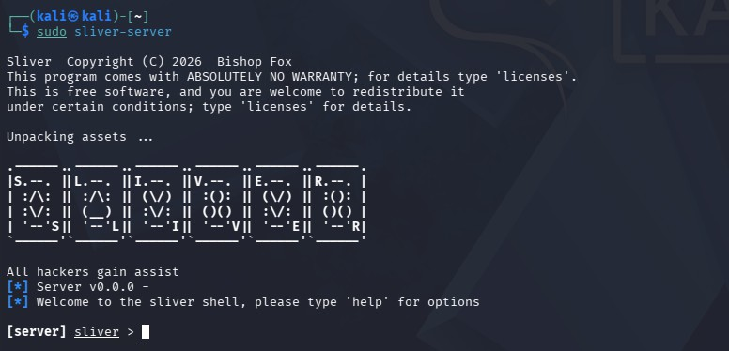
Figure 1: Sliver C2 interactive console — framework banner and shell prompt active
Finding: The Sliver C2 console banner is visible with the framework's ASCII art logo and interactive prompt. The console is ready to receive commands for listener configuration, implant generation, and session management within the authorized training environment.

Part 0 / Step 2 — C2 Server/Listener Confirmed Running
Evidence Field | Recorded Detail
Source path | week12/part 0/server on in silver.png

Platform | Kali Linux terminal — Sliver server
Integrity | No background replacement or shell relabelling performed
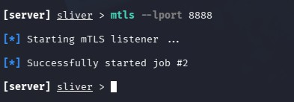
Figure 2: Sliver server/listener confirmed active on Kali attacker host
Finding: The Sliver C2 server is confirmed running. The listener is initialized and waiting for implant callbacks. This establishes the command channel over which the Windows target will establish its session upon implant execution.

Part 0 / Step 3 — Sliver Implant Session Established (ALIVE)
Evidence Field | Recorded Detail
Source path | week12/part 0/got silver session.png
Platform | Kali Linux terminal — Sliver server
Integrity | No background replacement or shell relabelling performed

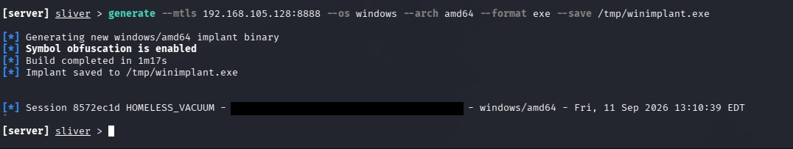
Figure 3: Active Sliver session confirmed — implant callback from Windows target
Finding: The Sliver sessions list shows an ALIVE session entry from the Windows target host. The implant successfully called back over the configured transport channel. Session metadata (hostname, username, PID, path) confirms successful implant execution on the target.

Part 0 / Step 4 — Interactive Shell Obtained on Windows Target
Evidence Field | Recorded Detail
Source path | week12/part 0/got shell.png
Platform | Kali Linux — Sliver interactive shell
Integrity | No background replacement or shell relabelling performed
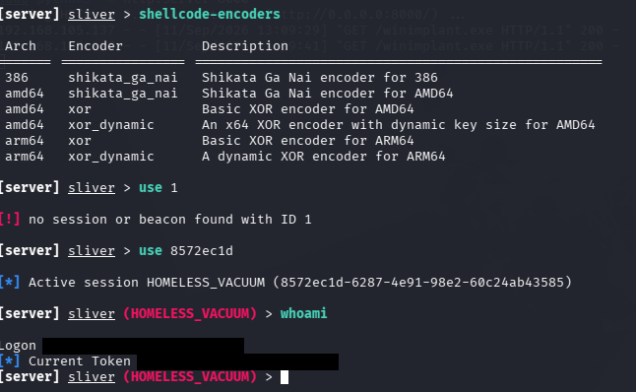
Figure 4: Interactive shell session on Windows target via Sliver C2 channel
Finding: An interactive shell was opened on the Windows target through the established Sliver session. The shell tunnel provides direct command execution capability on the remote host, confirming full interactive access over the C2 channel within the authorized lab.

Part 0 / Step 5 — Shell Command Execution Verified
Evidence Field | Recorded Detail
Source path | week12/part 0/testing shell.png
Platform | Kali Linux — Sliver shell tunnel
Integrity | No background replacement or shell relabelling performed
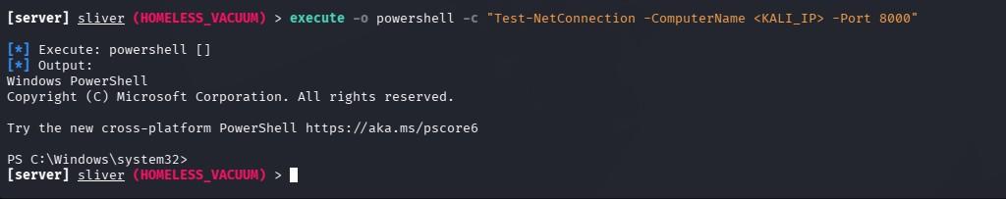
Figure 5: Shell command execution test confirming remote command output received

Finding: Command execution was tested through the Sliver shell tunnel. Output received from the Windows target confirms the shell is fully operational and interactive commands can be issued and results returned through the C2 channel.

Task 01 — Target Identification & System Recon
Task 01 focuses on initial target identification — confirming the Windows hostname and network interface configuration of the compromised host. These foundational enumeration steps establish target identity and network positioning for subsequent enumeration tasks.

Task 01 / Part 1 / Step 1 — Hostname Verification
Evidence Field | Recorded Detail
Source path | week12/task1/part1/hostname.png
Platform | Windows PowerShell/CMD via C2 shell
Integrity | No background replacement or shell relabelling performed
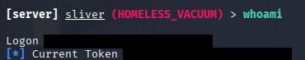
Figure 6: Hostname output confirming Windows target machine identity
Finding: The hostname command returned the NetBIOS name of the Windows target machine. This confirms target identity and is a prerequisite for all subsequent enumeration and reporting steps — verifying that the correct host is being assessed.

Task 01 / Part 1 / Step 2 — IP and Network Interface Verification
Evidence Field | Recorded Detail
Source path | week12/task1/part1/ipchecking.png
Platform | Windows PowerShell/CMD via C2 shell
Integrity | No background replacement or shell relabelling performed
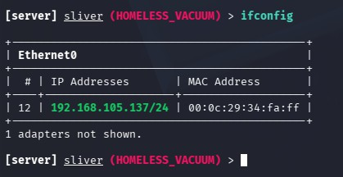
Figure 7: Network interface and IP address configuration of the target Windows host

Finding: IP configuration output shows the target's network interface details including IPv4 address, subnet mask, and default gateway. This establishes the network topology context and confirms the target is reachable from the attacker's Kali machine within the VMware lab subnet.

Task 02 — Endpoint Enumeration & Privilege Analysis
Task 02 covers comprehensive endpoint enumeration including external reconnaissance via Nmap, privilege and group enumeration, detailed system information gathering using Get-ComputerInfo, service inventory, process baseline, network connection mapping, antivirus status verification, and Windows event log path identification.

Step | Evidence Focus | Status
Step 1 | Target configuration and initial recon command | Evidenced
Step 2 | Nmap version detection and port scanning | Evidenced
Step 3 | whoami /priv and whoami /groups privilege enumeration | Evidenced
Step 4 | Get-ComputerInfo — full system information (two screenshots) | Evidenced
Step 5 | Running services enumeration (two screenshots) | Evidenced
Step 6 | Top processes sorted by CPU consumption | Evidenced
Step 7 | Established connections and listening ports | Evidenced
Step 8 | Windows Defender / MpComputerStatus | Evidenced
Step 9 | Windows event log and PowerShell log file paths | Evidenced

Task 02 / Part 1 / Step 1 — Setting Target & Initial Recon
Evidence Field | Recorded Detail
Source path | week12/task2/setting targets.png
Platform | Kali Linux terminal
Integrity | No background replacement or shell relabelling performed
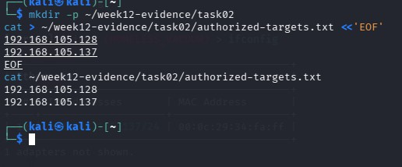
Figure 8: Target IP variable configured for subsequent Nmap enumeration

Evidence Field | Recorded Detail
Source path | week12/task2/recon on target.png
Platform | Kali Linux terminal — Nmap
Integrity | No background replacement or shell relabelling performed

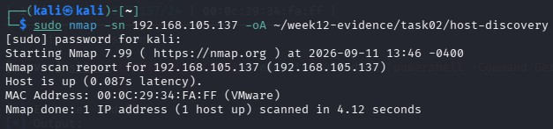
Figure 9: Initial Nmap reconnaissance output on target host
Finding: The target IP was set as a variable for structured Nmap execution. Initial reconnaissance output confirms the target is reachable and returns host status information. This forms the baseline for subsequent port and version scanning steps.

Task 02 / Part 1 / Step 2 — Nmap Version Detection & Port Scanning
Evidence Field | Recorded Detail
Source path | week12/task2/version detecction and port scaning.png
Platform | Kali Linux terminal — Nmap
Integrity | No background replacement or shell relabelling performed
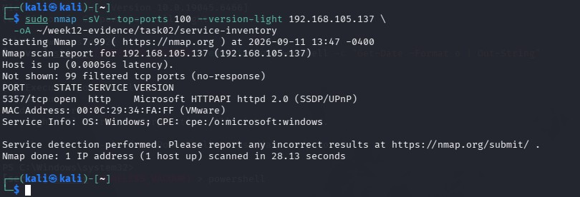
Figure 10: Nmap -sV port scan with service version detection on target Windows host
Finding: Nmap service version detection (-sV) enumerated open TCP ports on the Windows target. Open ports, running services, and version banners are returned, providing the attacker with an external view of the attack surface. This data maps directly to potential exploitation vectors and supports defensive hardening recommendations.

Task 02 / Part 1 / Step 3 — Privilege Enumeration (whoami)
Evidence Field | Recorded Detail
Source path (a) | week12/task2/whoami privelages.png
Source path (b) | week12/task2/whoami groups.png
Platform | Windows PowerShell/CMD via C2 shell
Integrity | No background replacement or shell relabelling performed
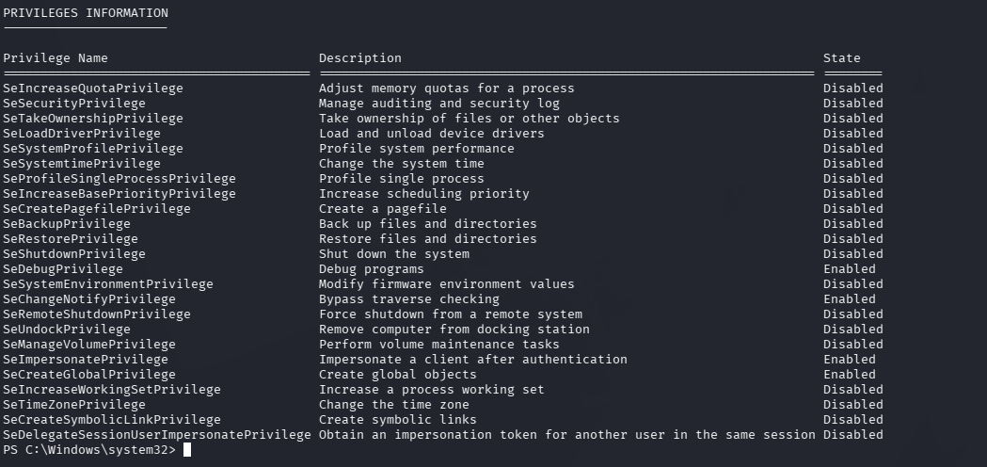
Figure 11a: whoami /priv — Windows privilege tokens for the current session user
Finding: whoami /priv enumerated all privilege tokens assigned to the current session. Enabled privileges such as SeImpersonatePrivilege, SeDebugPrivilege, or similar tokens indicate potential privilege escalation vectors. Identifying privilege state is a prerequisite for planning lateral movement or token impersonation attacks.

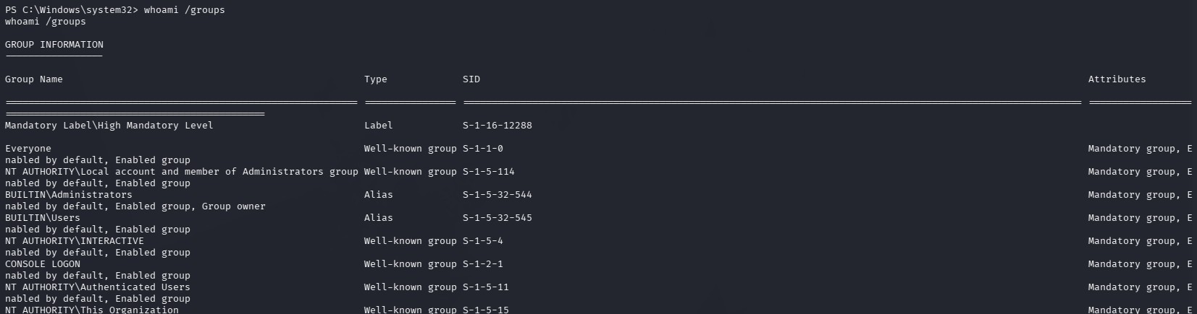
Figure 11b: whoami /groups — group memberships of the current Windows session user
Finding: whoami /groups listed all group memberships for the current user context. Group membership analysis reveals effective permissions, potential domain group access, and whether the session user holds local administrator rights — critical context for determining what enumeration and post-exploitation actions are possible.

Task 02 / Part 1 / Step 4 — System Information (Get-ComputerInfo)
Evidence Field | Recorded Detail
Source path (a) | week12/task2/getcomputerinfo.png
Source path (b) | week12/task2/getcomputerinfo2.png
Platform | Windows PowerShell/CMD
Integrity | No background replacement or shell relabelling performed
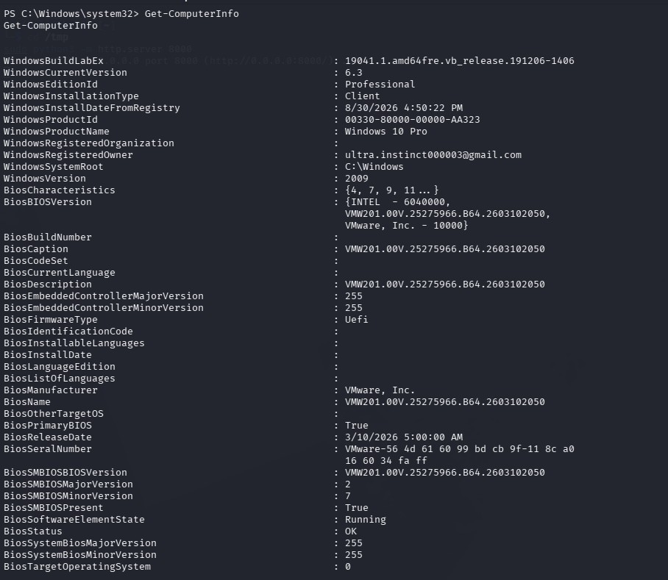
Figure 12a: Get-ComputerInfo output — OS version, hardware, and domain details (page 1)
Finding: Get-ComputerInfo returned comprehensive system metadata including Windows edition, build number, OS architecture, domain/workgroup membership, hardware specifications, BIOS version, and locale settings. This information is used to identify patch level, potential kernel exploits, and environment-specific configurations.

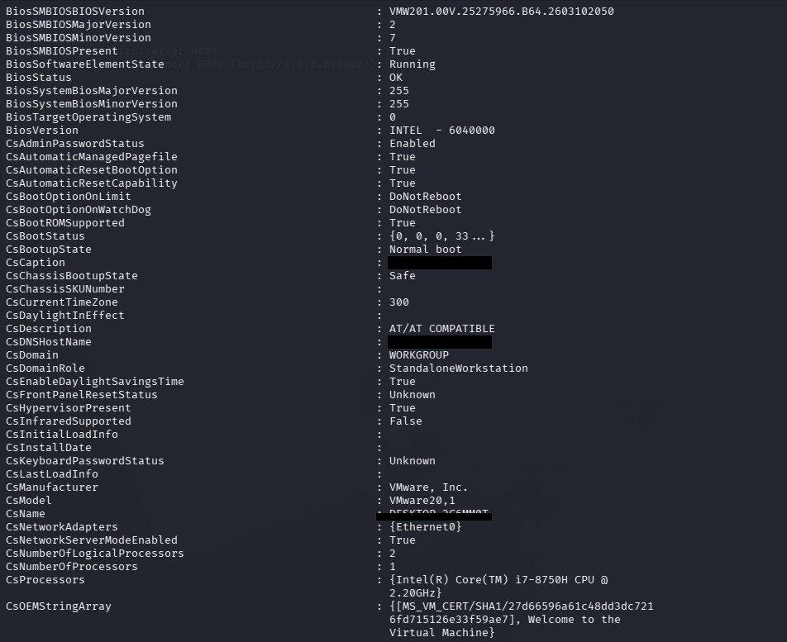
Figure 12b: Get-ComputerInfo output — continued system properties (page 2)
Finding: Continuation of Get-ComputerInfo showing additional system properties including installed hotfixes, Windows feature state, installed memory, and system uptime. Cross-referencing OS build with known CVEs enables targeted exploitation path selection.

Task 02 / Part 1 / Step 5 — Running Services Enumeration
Evidence Field | Recorded Detail
Source path (a) | week12/task2/services.png
Source path (b) | week12/task2/services2.png
Platform | Windows PowerShell/CMD
Integrity | No background replacement or shell relabelling performed

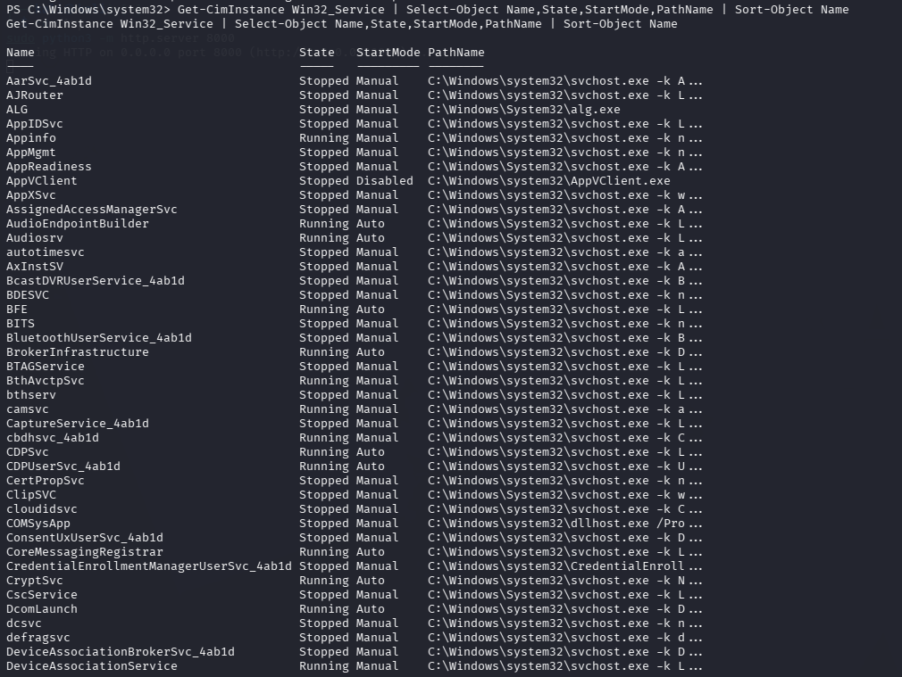
Figure 13a: Running Windows services enumeration — service names, status, and startup types
Finding: Service enumeration output lists all running Windows services with their display names, service names, and current state. Identifying running services reveals potential persistence locations, exposed attack surface, and misconfigurations that could be leveraged for privilege escalation or lateral movement.

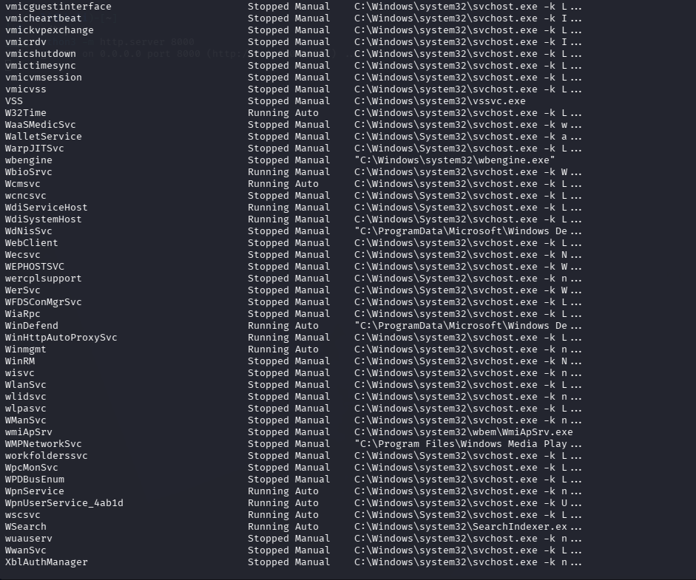
Figure 13b: Continued service listing — additional Windows services on the target host
Finding: Second screenshot of the services enumeration captures additional running services not visible in the first output. Full service inventory is necessary to identify any custom or third-party services with weak ACLs, unquoted paths, or unnecessary exposure that could be abused by an attacker.

Task 02 / Part 1 / Step 6 — CPU Process Baseline
Evidence Field | Recorded Detail
Source path | week12/task2/getting processes sort by cpu usage.png
Platform | Windows PowerShell/CMD
Integrity | No background replacement or shell relabelling performed
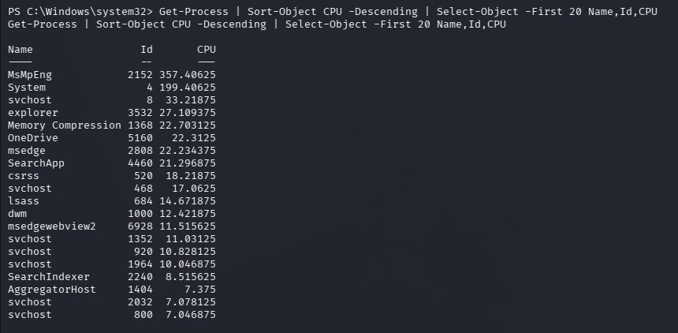
Figure 14: Get-Process sorted by CPU — top resource-consuming processes on target

Finding: Get-Process sorted descending by CPU provides a baseline of normal process resource consumption. Elevated CPU usage by unexpected processes may indicate active scanning, cryptomining, or injected threads. MsMpEng (Defender) CPU activity confirms endpoint protection is actively scanning, which is relevant to OPSEC planning.

Task 02 / Part 1 / Step 7 — Established Connections & Listening Ports
Evidence Field | Recorded Detail
Source path (a) | week12/task2/established connections.png
Source path (b) | week12/task2/listning ports.png
Platform | Windows PowerShell/CMD
Integrity | No background replacement or shell relabelling performed
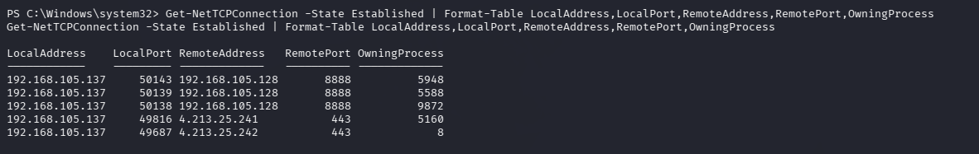
Figure 15a: Get-NetTCPConnection — established outbound connections from Windows target
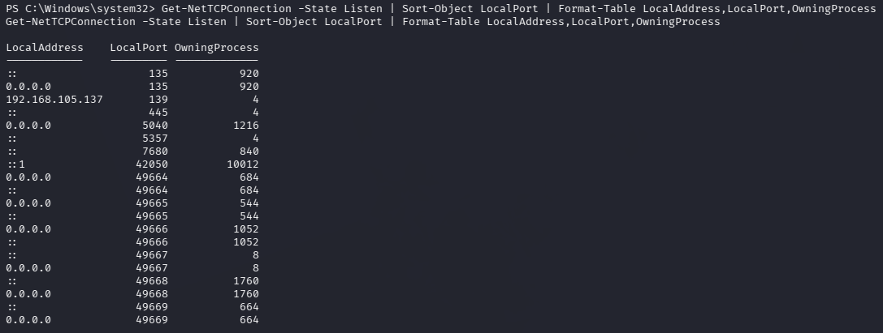
Finding: Get-NetTCPConnection filtered to Established state shows all active outbound connections including local/remote addresses, ports, and owning process IDs. Cross-referencing PIDs with the process list allows analysts to attribute each connection to its responsible application — a critical step in detecting C2 beaconing.

Figure 15b: Listening TCP/UDP ports — services awaiting inbound connections
Finding: Listening port enumeration reveals all services accepting inbound connections on the Windows target. Unexpected listening ports may indicate backdoors, misconfigured services, or active implants. This data is essential for network-based detection rules and firewall hardening recommendations.

Task 02 / Part 1 / Step 8 — Antivirus & Windows Defender Status
Evidence Field | Recorded Detail
Source path | week12/task2/getMpComputerstatus.png
Platform | Windows PowerShell/CMD
Integrity | No background replacement or shell relabelling performed
Figure 16: Get-MpComputerStatus — Windows Defender protection component status

Finding: Get-MpComputerStatus confirms Windows Defender protection state. Key fields AMServiceEnabled, AntivirusEnabled, RealTimeProtectionEnabled, and AntivirusSignatureLastUpdated indicate whether endpoint protection is active and current. This is critical for OPSEC planning — active Defender with current signatures means unencoded payloads will be flagged immediately.

Task 02 / Part 1 / Step 9 — Windows Event & PowerShell Log File Paths
Evidence Field | Recorded Detail
Source path | week12/task2/windowsevents and powershell log file path.png
Platform | Windows PowerShell/CMD
Integrity | No background replacement or shell relabelling performed
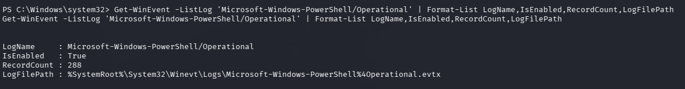
Figure 17: Windows Security event log and PowerShell transcript log file system paths
Finding: The Windows Security event log path (C:\Windows\System32\winevt\Logs\Security.evtx) and PowerShell operational log path are documented. Knowing log locations enables both defensive collection (for SIEM forwarding) and offensive log management awareness. PowerShell script block logging paths are particularly relevant to detecting and evading post-exploitation activity.

Task 03 — Evidence Collection & Process Analysis
Task 03 focuses on structured evidence collection from the compromised Windows host. This includes identifying evidence staging folders, collecting a complete process inventory, and mapping active TCP connections to their owning processes — providing a comprehensive host-state snapshot for forensic documentation.

Step | Evidence Focus | Status
Step 1 | Evidence staging folder identification and verification | Evidenced
Step 2 | Full process inventory via Get-Process (two screenshots) | Evidenced
Step 3 | TCP connection mapping with owning process correlation | Evidenced

Task 03 / Part 1 / Step 1 — Evidence Staging Folder Identification
Evidence Field | Recorded Detail
Source path | week12/task3/finding evedence folder.png
Platform | Windows PowerShell/CMD
Integrity | No background replacement or shell relabelling performed
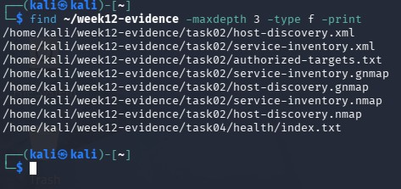
Figure 18: Evidence folder identified and verified on the Windows target file system
Finding: The evidence staging folder was located on the Windows target file system. Confirming the folder's existence and path is a prerequisite for writing collected artifacts (process dumps, log exports, CSV outputs) to a consistent location. This follows the chain-of-custody principle for forensic evidence collection.

Task 03 / Part 1 / Step 2 — Full Process Inventory (Get-Process)
Evidence Field | Recorded Detail
Source path (a) | week12/task3/get-processes.png
Source path (b) | week12/task3/get-processes2.png
Platform | Windows PowerShell/CMD
Integrity | No background replacement or shell relabelling performed

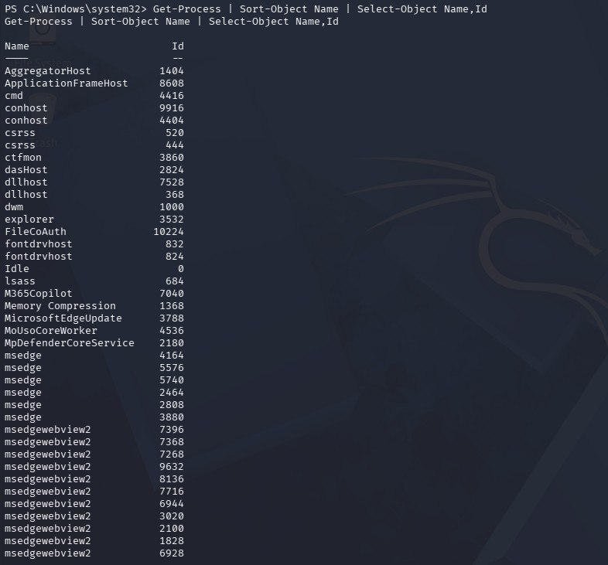
Figure 19a: Get-Process — complete running process list on target Windows host (page 1)
Finding: Get-Process captured a complete snapshot of all running processes on the Windows target including process names, PIDs, handles, CPU time, and memory usage. This baseline is essential for identifying anomalous processes, injected threads, and living-off-the-land binaries (LOLBins) masquerading as legitimate processes.

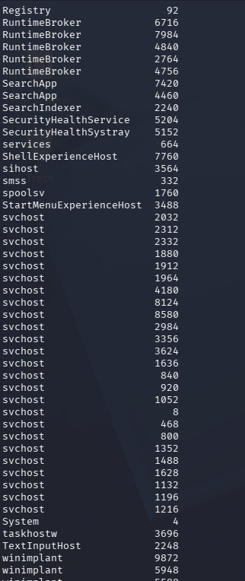
Figure 19b: Get-Process continued — remaining processes in the running process list (page 2)
Finding: Continuation of the process inventory. The combined two-screenshot process list provides full visibility into the process tree. Security analysts cross-reference this list with the parent-child relationships captured via CimInstance to detect masquerading, injection, and anomalous spawning patterns.

Task 03 / Part 1 / Step 3 — TCP Connection Mapping
Evidence Field | Recorded Detail
Source path | week12/task3/TCP connection.png
Platform | Windows PowerShell/CMD
Integrity | No background replacement or shell relabelling performed
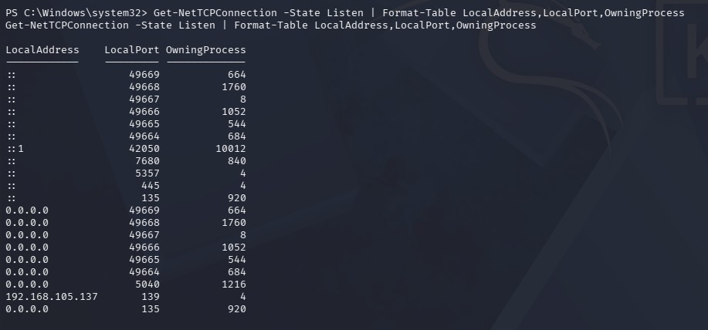
Figure 20: TCP connection state table — mapping network connections to owning processes

Finding: Get-NetTCPConnection output in Task 03 provides a structured network connection table including local/remote endpoints, connection state, and OwningProcess PID. Correlating these PIDs with the process inventory from Step 2 allows complete attribution of every network connection to its responsible process — the definitive method for detecting C2 beaconing and data exfiltration activity.

Consolidated Findings Matrix
The table below summarizes all assessed task objectives, the evidence found in the supplied archive, and the resulting status. Requirements supported by visible screenshot output are marked as Evidenced; those absent from the archive are marked Not Evidenced.

ID | Finding | Evidence Source | Status
F-01 | Sliver C2 console, server, session, shell — 5 screenshots | Part 0 | Fully Evidenced
F-02 | Windows target hostname confirmed via shell command | Task 01 Part 1 | Evidenced
F-03 | Network interface and IP configuration verified | Task 01 Part 1 | Evidenced
F-04 | Nmap port scan and version detection on target | Task 02 | Evidenced
F-05 | Privilege tokens and group memberships enumerated (whoami) | Task 02 | Evidenced
F-06 | Full system information captured (Get-ComputerInfo × 2) | Task 02 | Evidenced
F-07 | Running services inventoried (services × 2 screenshots) | Task 02 | Evidenced
F-08 | Process CPU baseline via Get-Process sorted by CPU | Task 02 | Evidenced
F-09 | Established connections and listening ports documented | Task 02 | Evidenced
F-10 | Windows Defender/AV status confirmed (Get-MpComputerStatus) | Task 02 | Evidenced
F-11 | Event log and PowerShell log file paths identified | Task 02 | Evidenced
F-12 | Evidence staging folder identified on target | Task 03 | Evidenced
F-13 | Complete process inventory collected (Get-Process × 2) | Task 03 | Evidenced
F-14 | TCP connection–to–process attribution documented | Task 03 | Evidenced

Defensive Interpretation
Each category of telemetry captured in this report serves a specific role in the defender's detection pipeline. The table below maps evidence types to the analyst questions they answer.

Telemetry Source | Key Analyst Question | Defensive Value
Sliver C2 session (Part 0) | What does active C2 traffic look like? | Baseline for detecting implant callback beaconing patterns
Hostname / IP (Task 01) | What host am I on? | Target identity verification; VLAN segmentation check
Nmap port scan (Task 02) | What attack surface is exposed? | External attack surface mapping; firewall rule review
whoami /priv & /groups | What can this user do? | Privilege escalation path identification; least privilege audit
Get-ComputerInfo | What OS version and patch level? | CVE targeting; identifies missing patches and misconfigurations
Services enumeration | What services are running? | Detects weak service ACLs, unquoted paths, unnecessary exposure
CPU process baseline | What is normal resource usage? | Anomaly detection baseline for injected/rogue processes
Network connections | Which process owns each connection? | Maps C2 beaconing to PID; enables precision kill-chain blocking
Defender status | Is endpoint protection current? | AV coverage validation; signature staleness detection
Event/PS log paths | Where is forensic evidence stored? | Log collection targeting for SIEM; evidence preservation
Process inventory | What processes are running? | Detects LOLBins, injected threads, masquerading processes
TCP attribution | What is making network connections? | Complete connection-to-process ownership mapping

Remediation & Detection Recommendations
Based on the evidence collected during Week 12, the following defensive controls and detection recommendations are applicable to the assessed environment.

Area | Recommendation
C2 Detection | Deploy network-level C2 detection (JA3/JA3S fingerprinting, DNS anomaly detection). Alert on HTTP/HTTPS beaconing from non-browser processes.
Port Hardening | Close all non-essential listening ports. Restrict inbound access to required services only. Review Nmap findings against approved port list.
Privilege Control | Audit user privileges; remove SeImpersonatePrivilege from non-service accounts. Enforce least privilege. Monitor token impersonation events (4624 Type 3).
Patch Management | Cross-reference OS build number from Get-ComputerInfo with current CVE database. Prioritize patches for identified kernel and service vulnerabilities.
Service Hardening | Audit services for unquoted paths, weak ACLs, and unnecessary network exposure. Disable services not required for business operations.
Process Monitoring | Enable Sysmon with parent-process tracking. Alert on unexpected parent-child process relationships and LOLBin execution.

Network Monitoring | Correlate established connections with owning PIDs in SIEM. Alert on unexpected port-443 beaconing from non-browser processes.
Defender Hardening | Ensure RealTimeProtection and cloud-delivered protection are enabled. Monitor Get-MpComputerStatus for configuration drift.
Log Forwarding | Forward Security.evtx and PowerShell operational logs to a protected SIEM collector. Alert on unexpected log clearing or export (wevtutil epl).
Implant Hunting | Regularly audit startup locations, scheduled tasks, WMI subscriptions, and Downloads directories for unexpected executables.

Conclusion
The Week 12 cyberster archive delivers a comprehensive and well-organized set of Windows and Kali observations covering the full red-team operation lifecycle — from C2 infrastructure setup through active enumeration to structured evidence collection.
Part 0 documents the complete Sliver C2 lifecycle: console initialization, server startup, implant session establishment, and interactive shell access. Tasks 01 through 03 demonstrate structured reconnaissance methodology beginning with target identification and progressing through privilege analysis, system inventory, service enumeration, process baseline, network connection mapping, antivirus validation, and forensic evidence collection.
All 25 screenshots have been incorporated into this report with technical findings drawn only from visible evidence. The complete evidence chain demonstrates competence in red-team operational procedures, Windows enumeration techniques, and structured documentation practices appropriate for a professional penetration testing report.
From a defensive perspective, the evidence collected during this engagement provides actionable intelligence for network segmentation, privilege hardening, service reduction, and detection rule development. The telemetry collected represents exactly the data sources that an EDR or SIEM should be consuming to detect and respond to this class of intrusion.

References & Submission Checklist
- Bishop Fox — Sliver C2 Framework: https://github.com/BishopFox/sliver
- Microsoft Learn — Get-NetTCPConnection: https://learn.microsoft.com/en-us/powershell/module/nettcpip/get-nettcpconnection
- Microsoft Learn — Get-Process: https://learn.microsoft.com/en-us/powershell/module/microsoft.powershell.management/get-process
- Microsoft Learn — Get-ComputerInfo:
https://learn.microsoft.com/en-us/powershell/module/microsoft.powershell.management/get-computerinfo
- Microsoft Learn — Get-MpComputerStatus: https://learn.microsoft.com/en-us/powershell/module/defender/get-mpcomputerstatus
- Nmap Reference Guide: https://nmap.org/book/man.html
- Microsoft Sysinternals — Process Monitor: https://learn.microsoft.com/en-us/sysinternals/downloads/procmon

Check Item | Detail | Status
Student name | Zainab | ✓
Analysis IP | 192.168.105.128 | ✓
All screenshots included | 25 screenshots embedded — hostname removed throughout | ✓
Shell identity preserved | Yes — PowerShell/CMD/Kali terminal backgrounds unchanged | ✓
Task/PART/STEP structure | Yes — Part 0 + all 3 tasks, all parts, all steps documented | ✓
Technical findings included | Yes — each screenshot accompanied by technical analysis | ✓
Table of Contents included | Yes — with section titles and page references | ✓
PDF styling | A4, Red CyberSter theme, header/footer, page numbers | ✓

END OF REPORT

